*Team ORTIBAL APPOLO 3000:*   
**Milestone 1 Submission**

**Pilots**  
Wong Jin Fu Shaun  
Lim Koon Yi Gary  
  
**Flight Advisor**  
Ang Zhi Kai  
  
**Flight Mentor**  
Anand Sundaram

**Disclaimer**

This report was prepared for CP2106: Independent Software Development Project in compliance with the NUS Code of Student Conduct

**

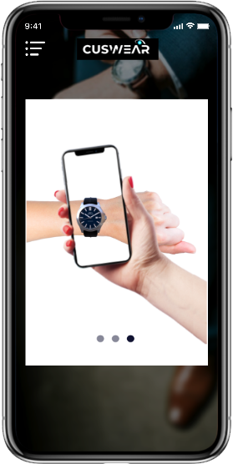*A* ***Mobile Application*** *that lets you try on different fashion products in* ***Augmented Reality****.*

**Proposed Level of Achievement:**

**Apollo 11**

**Figure 1:** Visual Representation Mock-up of CusWear Mobile App

**Aim**

To create a convenient platform that enhances the user shopping experience through innovative applications of augmented reality technology.

**Motivation & Need**

The e-commerce industry today is **saturated**, **fast-moving** and **competitive**. Businesses across the globe strive towards differentiating themselves by providing the best user experience. Yet, a significant portion of sales are lost or delayed because shoppers are **unable to confidently evaluate and envision** the sense of using the product when purchasing online.

**Augmented reality bridges this gap.** By helping users visualise the products in context of the physical space they are going to be used in, shoppers are more likely to feel comfortable in making a purchase. This is particularly so for products that rely heavily on aesthetic and appearance for sales—such as in the **fashion industry.**

Therefore, we have decided to build a mobile application that addresses this issue in this relatively new and unexplored space.

**User Stories**

1. **As a shopper**, I want to be able to visualise how a certain fashion product I buy online would look like on me without having to leave the comfort of my home.
2. **As an app user**, I want an easy-to-use platform that allows me to scan and see how I look like across a wide range of products.
3. **As an e-commerce business**, I want to provide my consumers with the best user shopping experience to incentivise them to purchase my products.

**Scope of Project**

Our entire project revolves around creating a **functioning mobile application** that is able to overlay 3D models of fashion items in augmented reality.

However, due to the nature of Orbital having only a short 3 months development span, we will be focusing on one item this summer—**watches**—as our **minimum viable product (MVP)**.

**Features (in order of priority):**

1. App allows users to scan and overlay a 3D watch model in augmented reality
2. App allows users to choose between different brands and categories of watches
3. App allows users to bookmark favourite watches
4. App allows users to take a photo or video of how it looks as it appears
5. App allows users to view the 3D models of watches in-app

Features 1 – 2 are core features for our project due for completion by **Milestone 2.**

Features 3 – 5 are possible extensions for our project due for completion by **Milestone 3**.

**Difference from Other Platforms**

**AR-Watches and other similar mobile apps**:   
  
AR-Watches is an excellent example that our idea exists in the market and works. However, many of these apps have not reached mass adoption. We feel that this is because they require users to print a tracker to be used concurrently.

To compensate this time and effort, we feel that users should be able to have access to multiple fashion products and brands. This is why our mobile app will eventually cover multiple fashion products (albeit out of the scope of this orbital project, to be developed after).  
 **Amazon, Etsy and almost every other mobile shopping app**:   
  
No large e-commerce retailer has really adopted augmented reality into their primary user shopping experience. Some of these apps allow you to view 3D models of the product, but do not allow an augmented reality overlay. We believe this is so because existing AR solutions out there are still not easily integrated or require too much work for each new 3D model.

We thus hope to create an app that potentially simplifies this whole process, making it easier for businesses to adopt our application to allow consumers to view and purchase their products.

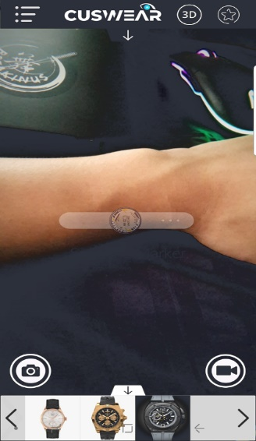**Program Flow**

3

2

4

1

1. Logo Screen
   1. User opens the app -> CUSWEAR logo appears
2. Categories Navigation Drawer
   1. User can select which category of clothing they would like to try on (i.e., watch, shoe, accessories etc. We will be implementing watches first as our MVP with the other categories as proof of concept for future development.)
3. Watch Brands Screen
   1. Users will be able to select the brand of watch they want to view
4. Scanning Screen
   1. 3D model of watch will overlay over worn tracker. 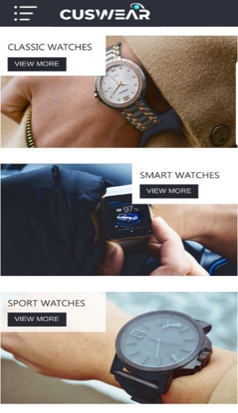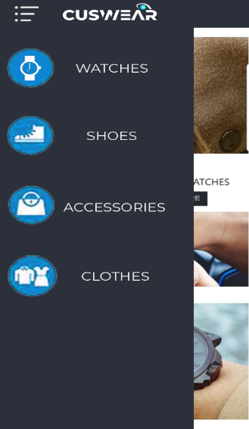Screen includes buttons to take photo, view watch info, favourite watch or view 3D model of the watch.

**Project Log**

|  |  |  |  |  |  |
| --- | --- | --- | --- | --- | --- |
| S/N | Task | Date | Orbitee 1 (hrs) | Orbitee 2 (hrs) | Remarks |
| 1 | Lift-off Day 1 | 13/5/2019 | 10 | 10 | Lift-off Day 1 |
| 2 | Lift-off Day 2 | 14/5/2019 | 9 | 9 | Lift-off Day 2 |
| 3 | Mission Control 1 | 18/5/2019 | 0 | 5 | ReactNative Workshop |
| 4 | Team Meeting 1 | 21/5/2019 | 5 | 5 | • Finalised project concept and idea  • Came up with project timeline and delegated roles  • Asked advisor and friends for feedback  • Applied for mentorship |
| 4 | Mission Control 2 | 25/5/2019 | 5 | 0 | Unity Workshop |
| 6 | Self-initiated Tasks | 26/5/2019 | 6 | 6 | • Learning of Unity, Vuforia and photogrammetry  • Practising with android studio |
| 7 | Self-initiated Tasks | 27/5/2019 | 6 | 6 | • Learning of Unity, Vuforia and photogrammetry  • Practising with android studio |
| 8 | Team Meeting 2 | 28/5/2019 | 10 | 10 | Worked on Milestone Submission (README) |
| 9 | Team Meeting 3 | 3/6/2019 | 4 | 4 | Worked on Milestone Submission (Video, Project Log) |
|  |  |  |  |  |  |

|  |  |  |
| --- | --- | --- |
| Total Hours | Orbitee 1 | Orbitee 2 |
| 112 | 56 | 56 |